**Somatic Symptom Scale – 8 (SSS-8)**

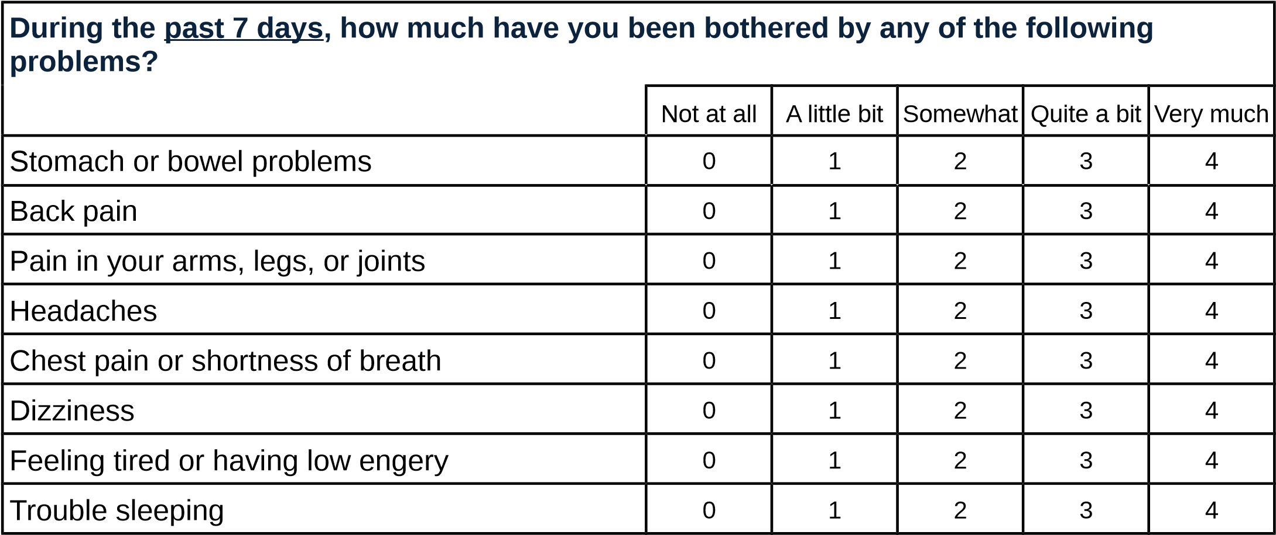

Client scored 21

Gierk B, Kohlmann S, Kroenke K, Spangenberg L, Zenger M, Brähler E, & Löwe B. (2014). The Somatic Symptom Scale–8 (SSS-8): A brief measure of somatic symptom burden. *JAMA Internal Medicine*, *174*(3), 399–407.